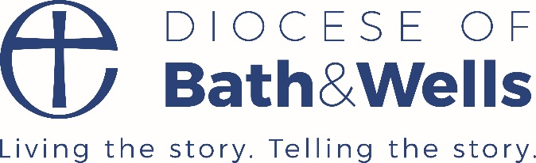
Presentation Ideas for RE (useful evidence for SIAMS or Ofsted)
- Create a class fact file, short film or a Powerpoint about a topic studied in the term i.e Holy Books, Places of Worship, Festivals, Understanding Christianity units
- Record a debate based on one of the big questions of life i.e ‘How did the world begin?’ (perhaps Understanding Christianity Creation unit). Include arguments from different religious and non-religious arguments
- The children could make an RE quiz for their parents or each other about everything they have learned during the unit of work
- Hot seating main characters from religious stories or act out a religious story. This could be recorded to show parents
- Invite parents into school for a coffee morning to share work and talk about what they have learned (one day soon!)
- Children create a crossword/word search using key religious vocab related to the unit of work for that term
- Children could write a poem or letter including some information learned from the RE unit of work
- Carry out home research about a key religious figure and produce a class book
- Have an exhibition of the children’s religious art work in the classroom or virtually. Perhaps display the art work in your local church.
- Enter the Spirited Arts competition: https://www.natre.org.uk/about-natre/projects/spirited-arts/spirited-arts-gallery/2020/
- Share great RE work on the school website, the newsletter or social media. Have a display board for RE in school celebrating good work each term

Based on a list prepared by Emma McCarthy, RE leader at Orchid Vale Primary School and Swindon Learn, Teach, Lead RE hub leader

Pauline Dodds
February 2021

